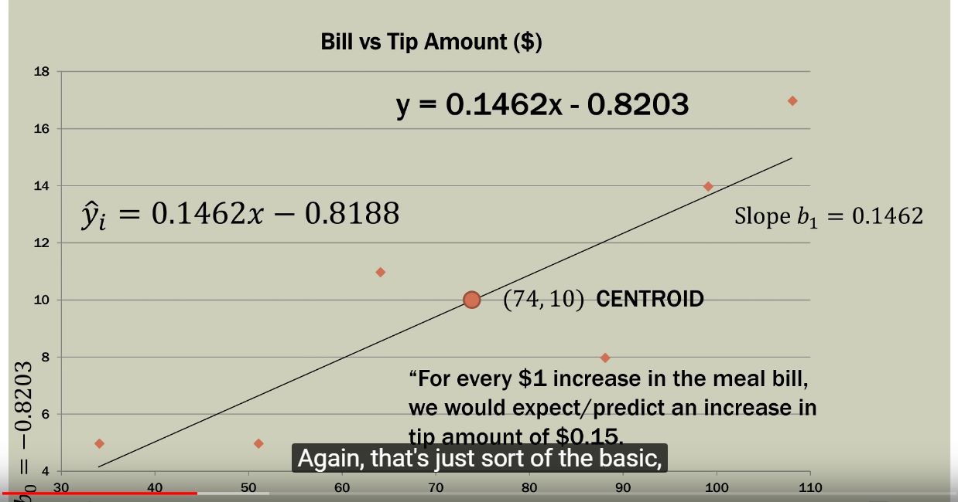

For every I unit increase in x axis term we would expect/predict an increase in y axis by it slope(m) in y=mx+c

**Confidence interval:** Mean value of y for a value of x.

Example: What could be the mean value of tip amount for a certain bill amount let it be 50 $

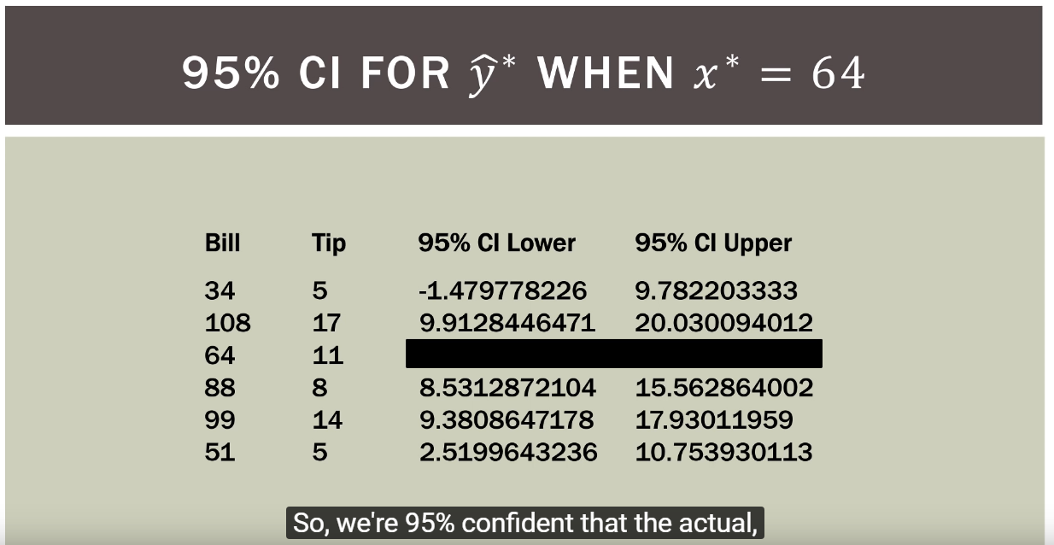

**95% Confidence interval** infers that range the tip would be for a particular amount on bill, i.e. for example if the bill was 51$, we are 95% confident that the tip could range from 2.5$(CI Lower limit) to $10.75(CI Upper Limit) , this is known as the confidence interval range.

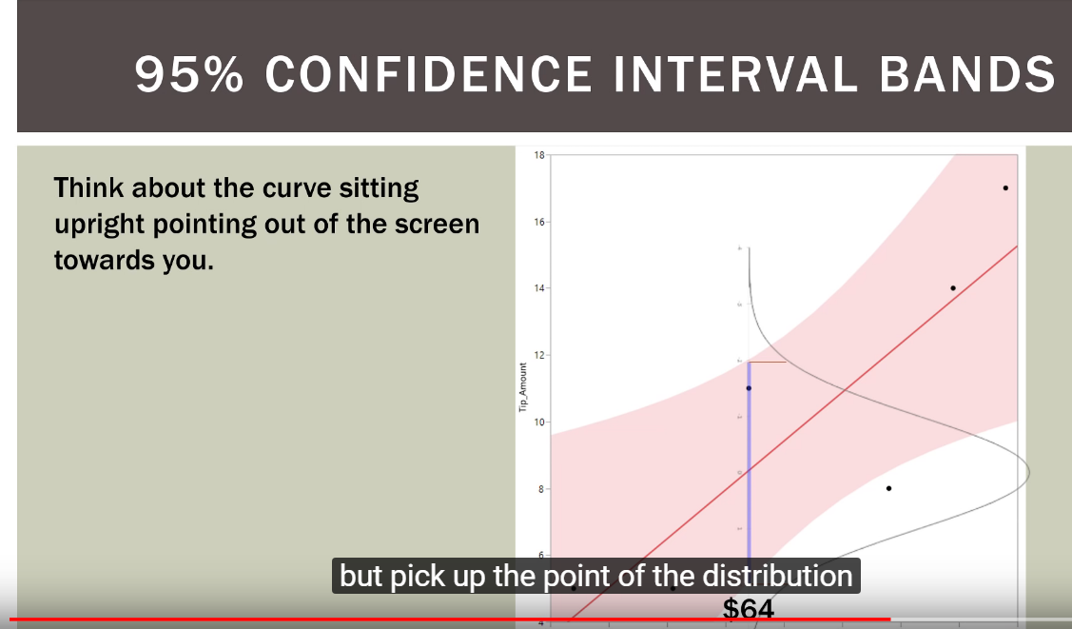

Here we are measuring the range of the Purple line, that is nothing but the confidence interval range.